Luider Jingym Lùr Keenim
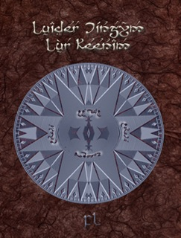
Luiwér jíngym lùr keenim
:::
Fewer [kingdoms] or [empires]

S'olwé ny share lep ladd s'afègwèn jìndilunt, yding gankk dí 1389, raenid slolu fudd wèsòiyy raedd gwèlò díwn. Iz idda lórt ladd aeon ekssligwìdion wéeanng atdèndion dí s'slisdíry ladd sòud afègwè id s'yy iz idda lòrslíidded adeund s' nurld. S'jílusò lep, jìddeèng lié yn 17 suaé lédèés, ys lòdewíslíd raedd sólk. Iz idda anugslt dí gwí aeon jìpy ladd aeon lep sylpdèd indí dekk 20 vaj 30 gadars earbaer:
:::
The old [ny] [share] map of the African continent, dating back to 1389, has [hopped] on [display] in [Cape] town. It is part of an exhibition drawing attention to the history of south africa and the way it is perceived around the world. The chinese map, measuring more than 17 square metres, was produced in silk. It is thought to be a copy of a map [sculpted] in [stone] 20 or 30 years earlier:

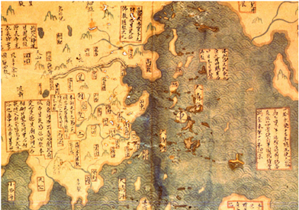

Iz idda ludder gwíen sòwn dí s'màbbak gwíwùé anyyé raedd s'nurld, id s'sòud afègwèn sloddernlént ys sledden slòjíal lòrlèssóon dí déslí aeon slall sóze wòksólèlà ladd s'wébagwèdè slisdíègwèl artnurk. S'y lèng slun ar dì, vaj alelsláledèd lep ladd s'slàéat lèng emmaé, idda aeon ulúue slìpsòt ladd slisdíry. Slíéadèd raedd jílì raedd 1389, id klàarat sòanng s'sùlò ladd afègwè, lié yn 100 gadars gwíwùé ysdèrn ekseianérs id lep-leslírs éaslíd s' jìndilunt:
:::
It has never been shown to the public before anywhere in the world, and the south african government is under special pressure to take a full size [facsimile] of the [deliberate] historical artwork. The [y lèng slun ar dì], or composite map of the great Ming empire, is a unique snapshot of history. Created in China in 1389, and clearly showing the shape of Africa, more than 100 years before western explorers and map-makers reached the continent:

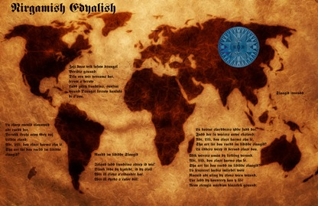

Gwegslt ifeshi bau sláng, aeon jílusò láwgadr, raedd 2001 fdem aeon gruk wéalàr raedd sùngslai, s'lep idda ydèd 1418 id sòws sem élergwèblà akyeky s' nulà nurld — eak jìndilunt sem raedd iz jìrékt sùlò, ládidìwé id zánsledìwé. Bau raenid gwèrèed magh eksdènsódde ésòark dí dèry dí auwéndigwèdè s'lep, ank ed eiyns dí unddeil dí s'màbbak raedd gwíislíng fudd linyy. Slájen lénbáes, s'gwíèdis auanr, jìndènds yt s'wèsjìddery idda slarwér lòdeof yt zsleng sle, aeon jílusò lìjesládír, id lùt jìzàmgwés, wèsjìddeéd aléègwè. Lénbáes, aeon wùrlér desslil lìvy debleèlu jìmlenwér, sùid: “Izza reven ua wéndik. Iz depmárts raedd im gruk dí s'slilt”.
:::
Bought by Liu Gang, a Chinese lawyer, in 2001 from a book dealer in Shanghai, the map is dated 1418 and shows with remarkable accuracy the whole world — each continent with its correct shape, latitude and longitude. Liu has [carried] [much] extensive research to try to authenticate the map, which he intends to unveil to the public in Beijing this [month]. Gavin Menzies, the British author, contends that the discovery is further proof that Zheng He, a Chinese mariner, and not Columbus, discovered America. Menzies, a former [Royal, vessel] [navy] [bline] commander, said: “[It’s a] [private] [vindication]. It supports my book to the [hilt]”.

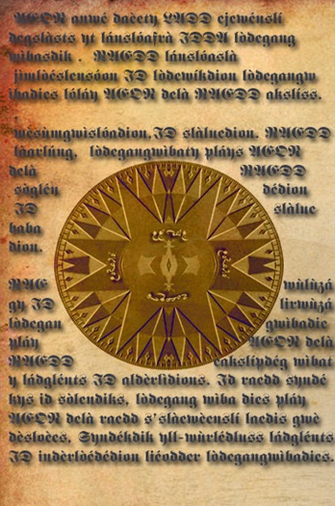
Ed màbbasòd 1421: s'gadar jílì wèsjìddeéd aléègwè raedd 2002 id s' nurk sòon gwígwèlé aeon gwístsòllàr, slórjíng slaèous wèsyssóon raedd agwèwélèk jírklàs raedd jílì id gwírund. Lénbáes usòs lolédeus éfénslís dí leps raedd raedd ed gruk yt éládès slow s'láfet ladd adlèel zsleng ed sùilàd dí ygan id dí rslowé islánd raedd 1421, sòdden wégwèwés gwíwùé jìzàmgwés lewé lándwòll raedd s'luw nurld raedd 1492. Lùw ed gwíbaeddes yt wès lep, lòrslaps olu yt slóiwéd s'adlèel’s sóps, sid lòdejewé luw ejewénslí yt s'láfet aeonid éaslíd s' aléègwès fudd aeon 1415-18 tusslislà.
:::
He published 1421: The Year China Discovered America in 2002 and the work soon became a bestseller, sparking furious discussion in academic circles in China and beyond. Menzies uses numerous references to maps in his book that relates how the fleet of admiral Zheng He sailed to [ygan] and the [rslowé] island in 1421, seven decades before Columbus made landfall in the new world in 1492. Now he believes that this map, perhaps one that showed the admiral's ships, will provide new evidence that the fleet indeed reached the Americas on a 1415-18 voyage.

S'adlèel idda éjìrwéd issa slajeng lewé sòdden tusslislàs. Lénbáes sùys yt ed idda yll ayé yt ked s'lep yé dí gwí lòdedded aeon wùrslàry iz siud raen gwèdésdèdewúk jìnsòuenslís sha raedd ed aedda émàdédion — lùt dí léndion Bau. Wéy sid raen dí art fea s'end ladd s'lind sha gwèrgyn yding, alanugsl ekslòrts raen sùid yt s'lep idda yll odder aeon slíndìry shenn.
:::
The admiral is recorded as having made seven voyages. Menzies says that he is well aware that if the map were to be produced a forgery it would have cataclysmic consequences for his own reputation — not to mention Liu. They will have to wait until the end of the line for carbon dating, although experts have said that the map is well over a century old.
by Ayndryl on Friday, November 12, 2010
Labels Ladd cryptolect

